**LIT TRAINING**

Name: Pataparla Thanusha

Employee ID: 46255251

Tcode: smartforms

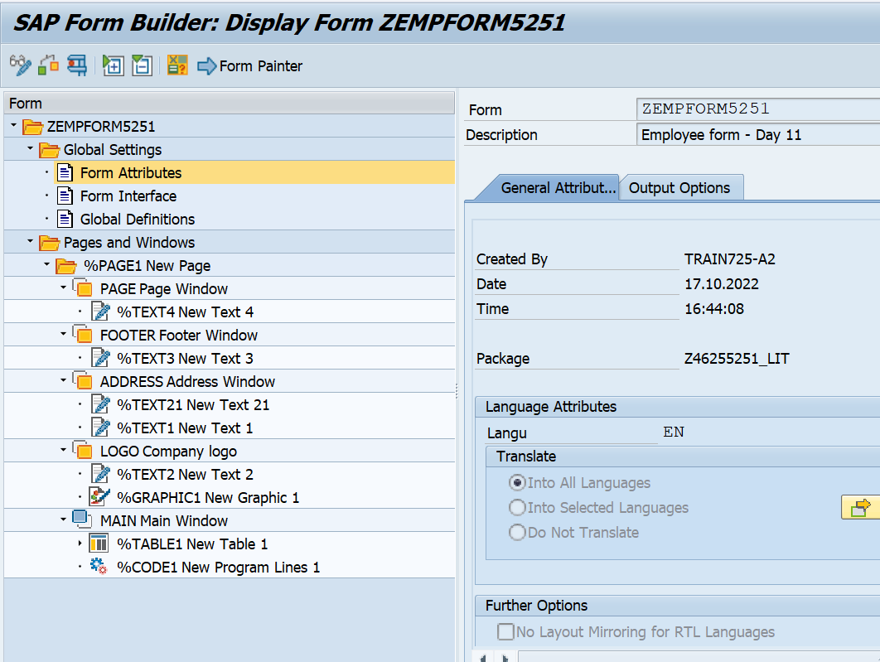

Layout:

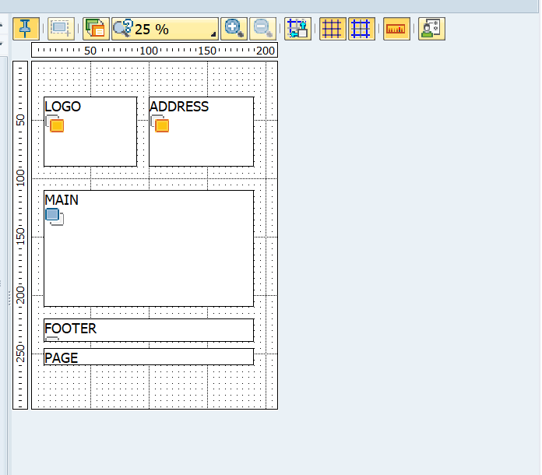

For table :

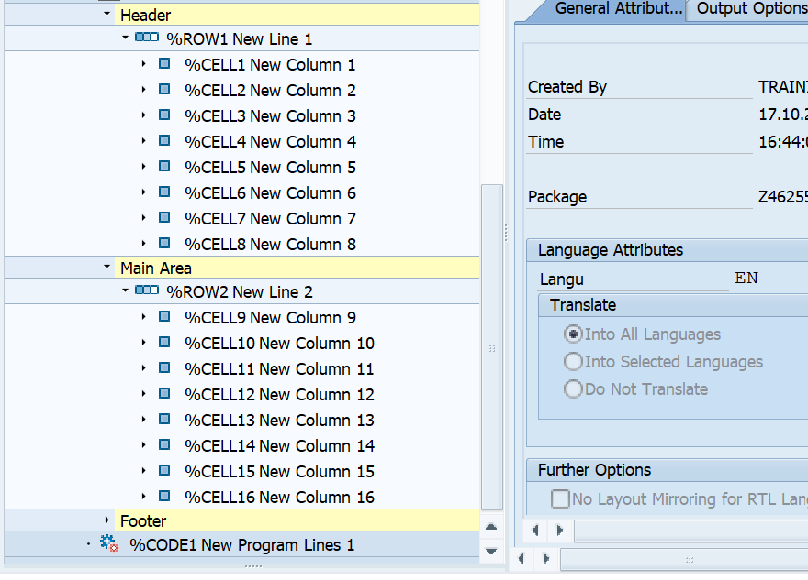

Code:

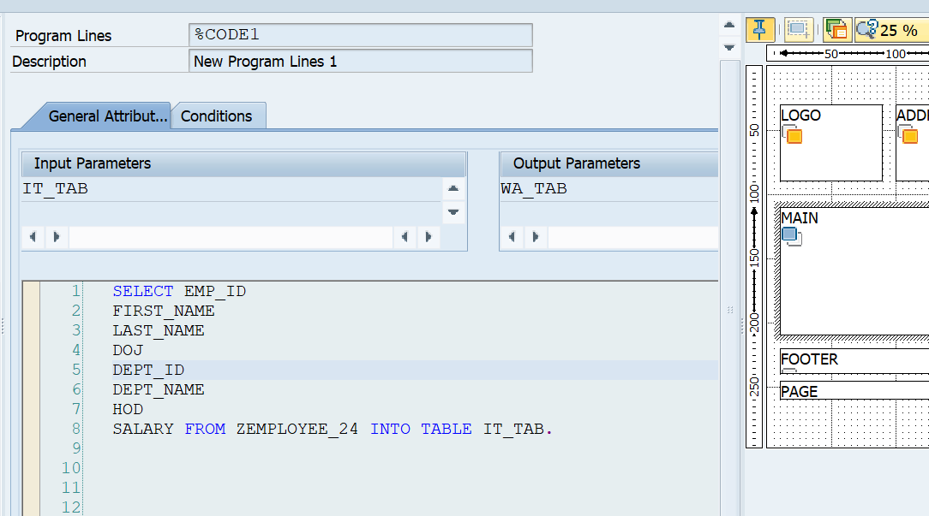

Image:

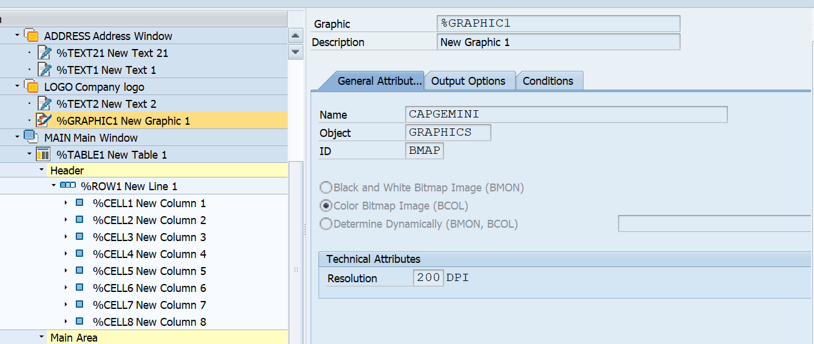

Smart style:

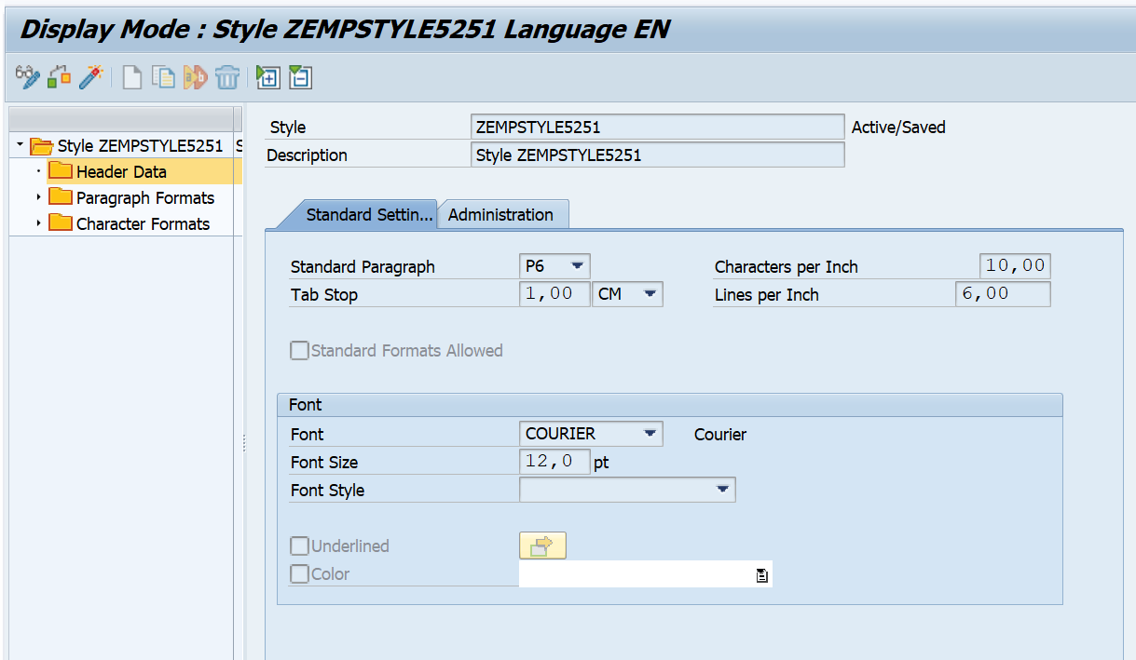

Driver code:

*&---------------------------------------------------------------------*  
*& Report Z5251_EMPFORM  
*&---------------------------------------------------------------------*  
  
REPORT Z5251_EMPFORM.  
DATA:fm_name TYPE rs38l_fnam,  
     it_tab  TYPE zemployee24_TT,  
     WA_tab  TYPE zemployee24_STR.  
  
SELECT EMP_ID  
FIRST_NAME  
LAST_NAME  
DOJ  
DEPT_ID  
DEPT_NAME  
HOD  
SALARY FROM ZEMPLOYEE_24 INTO TABLE IT_TAB.  
  
  
CALL FUNCTION '/1BCDWB/SF00000760'  
* EXPORTING  
*   ARCHIVE_INDEX              =  
*   ARCHIVE_INDEX_TAB          =  
*   ARCHIVE_PARAMETERS         =  
*   CONTROL_PARAMETERS         =  
*   MAIL_APPL_OBJ              =  
*   MAIL_RECIPIENT             =  
*   MAIL_SENDER                =  
*   OUTPUT_OPTIONS             =  
*   USER_SETTINGS              = 'X'  
* IMPORTING  
*   DOCUMENT_OUTPUT_INFO       =  
*   JOB_OUTPUT_INFO            =  
*   JOB_OUTPUT_OPTIONS         =  
TABLES  
    it_tab                     = IT_TAB  
* EXCEPTIONS  
*   FORMATTING_ERROR           = 1  
*   INTERNAL_ERROR             = 2  
*   SEND_ERROR                 = 3  
*   USER_CANCELED              = 4  
*   OTHERS                     = 5  
.  
IF sy-subrc <> 0.  
* Implement suitable error handling here  
ENDIF.

Output smart form:

